  - Future Chemists Wear Digital Lab Coats: Understanding Automation in Chemistry as Global Citizens (Note: 5 pages of writing + references for reference)
Digitizing Lab Coats
The classic image of a chemist wrapped in a lab coat may become obsolete within the next century due to automation. As technology has rapidly improved, automation systems have begun to outperform humans within the laboratory in efficiency and technique. Although promising, implementing automation is slow as automation systems are expensive, and chemists are apprehensive about the new technology. Chemists involved with automation warn that while automation has many benefits, progressing towards complete automation without sufficient regulation will likely result in an overdependence on automation systems and significant job displacements. As human involvement within chemistry diminishes, it is up to us, as global citizens, to ensure proper regulations are enacted to protect chemists and society. To make informed decisions and fully understand how automation will change chemistry, we need to understand where automation is applied, its broader effects, and what automation in chemistry is.
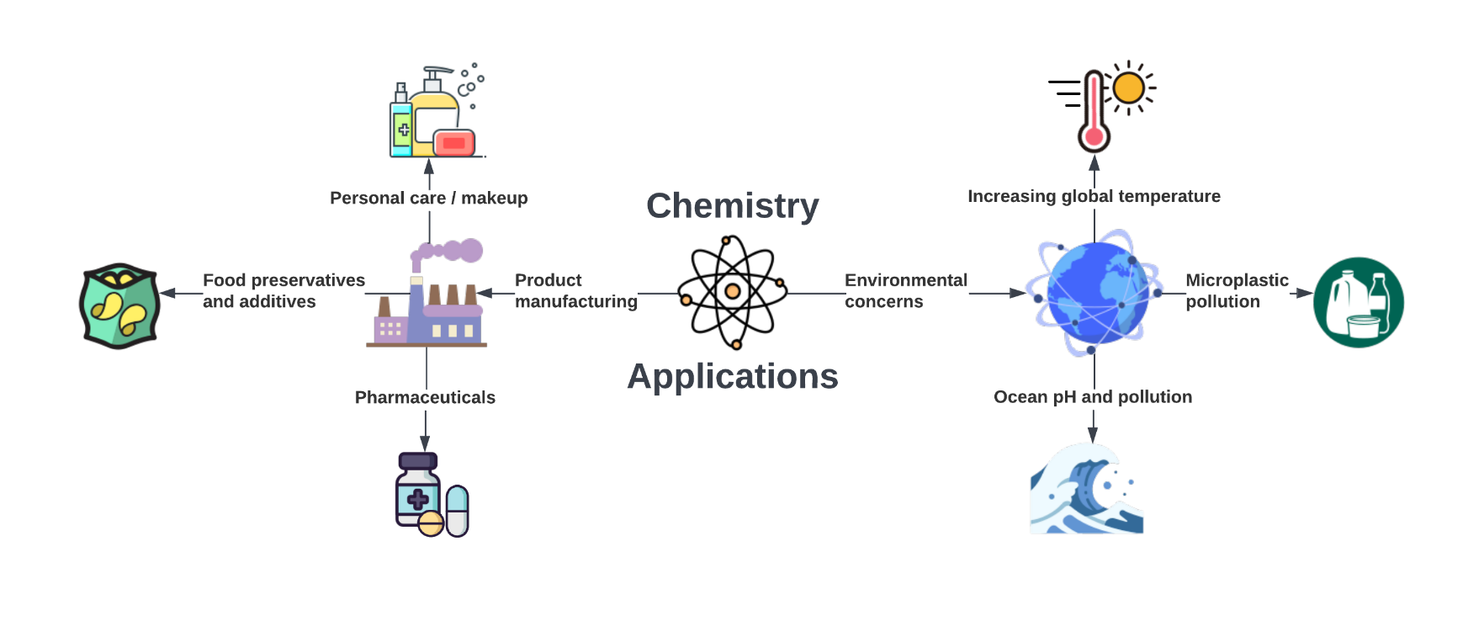
Chemistry and the World At Large

Chemistry is a central science pertinent to many aspects of our everyday lives, including the environment and product manufacturing, both of which automation is radically changing. Figure 1 showcases two specific areas that chemistry addresses, including several issues underlying climate change. As climate change has transformed into a climate crisis, countries pledge to enact profound changes that require significant global efforts to address it every year. This year, it was to prevent an increase in global temperature by decreasing greenhouse gas emissions by 45% over the next eight years.¹ Chemists are using automation to make this goal possible. Automation systems are more efficient than humans, as they can work exhaustively, over 20 hours per day and do not require breaks or rest.² They are also more accurate than humans, having greater precision and reproducibility, as they are not susceptible to human error.³ Practically, this results in faster, higher-quality research that creates biodegradable materials and cleaner manufacturing processes.^{4,5} Within the industrial sector, pharmaceutical companies are using automation to produce purer and, therefore, safer pharmaceuticals, allowing patients to be more confident in their treatment.⁶ ⁷ Manufacturing industries are also using automation systems to discover and bring new materials to market at unprecedented rates. With so many benefits, it seems peculiar that automation has yet to replace chemists entirely; however, there are challenges.
Figure 1 A diagram showing two relevant applications of chemistry to everyday lives. The left side shows manufacturing applications, which includes items such as pharmaceuticals, food preservatives and additives, and personal care. The right shows environmental applications that can be used to address pertinent issues such as increasing global temperature, microplastic pollution, and ocean pH and pollution. Original figure produced on Lucidchart (www.lucidchart.com), with icons from built-in Iconfinder.
Factors Prohibiting a Complete Automation
Automation lags in full implementation within chemistry due to the cost and commercial availability. Automation systems are exceedingly expensive. Simple machines useful for running one type of analysis based on one property, or performing only several reactions, cost thousands to tens of thousands of dollars.^{8–10} More advanced, universal machines, which can perform over 500 simple reactions or transfer objects around a room, are exponentially more expensive, costing hundreds of thousands of dollars per unit, excluding software.¹⁰ The commercial availability of automation systems is also limited, with only a small range of automated systems currently available for purchase. With many industries having optimized their reactions to particular conditions, appropriate systems are not commercially available and must be custom-made, further increasing the price.¹¹ Money is always a priority in labs due to limited funding and in industry for the highest profit margins. Thus, if proposed solutions are not economic, they are not solutions.
While specialised systems optimized for a specific reaction perform better than universal systems, one chemist can currently perform the role of several machines. In the lab, chemists execute many duties: designing experiments, choosing appropriate reagents and equipment, combining apparatus for creative problem-solving, and analyzing their product results to confirm they created the correct compound with few contaminants or by-products. Their work is equivalent to several specialised machines or a few universal machines. Figure 2 displays this ratio. It is cheaper and more accessible for chemists to do laboratory work themselves than adapt to, and learn about, several new machines. Chemists also resist implementing automation due to fears of being replaced, as automation systems are already at the technical proficiency of undergraduate chemists.¹²
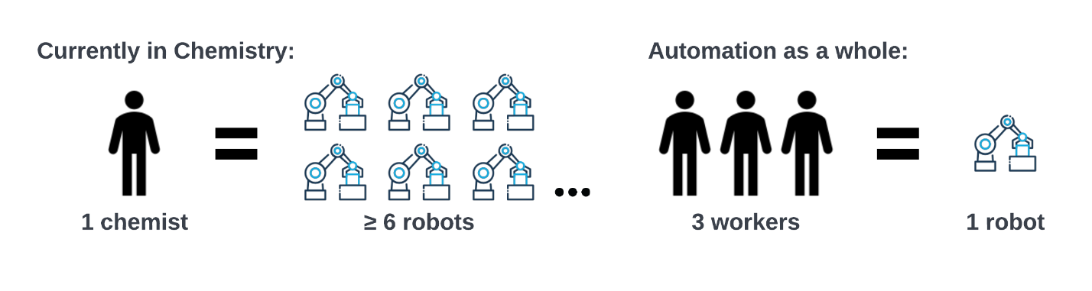
Figure 2 A comparison of the replacement ratio between humans and robots for chemistry (1:6+) and workers to robots (3:1) in the general workforce. Created from data from the US workforce from Acemoglu, D. et. al., 2022.¹³
Chemists are concerned about job displacement since most countries lack regulations preventing automation systems from replacing workers. Although currently cost-prohibitive, employers will inevitably replace chemists with automation systems once cost-permitting. Where companies have already employed automation, it has replaced around three workers with one machine, as shown in figure 2.¹³ Corporations also prefer machines as they do not take breaks, conform to labour laws, and can work exhaustively, day and night. Yet, we are at risk for consequences such as elevated unemployment, as Canada lacks regulation regarding automation implementation within all fields, chemistry included. Only earlier in June of this year, the Canadian Government introduced its first bill to enact automation regulation.¹⁴ The bill, still under consideration, will mandate audits and transparency of automation software systems.¹⁴ The bill does not cover automation hardware or implementation ethics. Similar policies are under consideration in the EU and the United States.¹⁵ However, workers across all sectors are at risk without any protections regarding implementing automation systems.
Beyond personal interests, chemists are also concerned about how over-dependence on technology could cause significant delays. Automation infrastructure is vulnerable to natural disasters or cyber-attacks due to their design specificity.¹⁶ Depending on the severity, these events could shut down automated systems for hours to weeks. As we are already dependent on companies for manufacturing our items such as food, pharmaceuticals, and cosmetics, these shutdowns would cause severe shortages and cascading economic harm.¹⁷ Thus, in enacting legislature we must emphasize the importance of building resilient automation systems as it is an extra cost that industries will try to avoid. Several disasters had to occur before governments enacted strict building codes; we are liable to a similar pattern unless we ensure regulation pre-emptively requires stable and secure automation systems.¹⁸ But what are scientists currently automating within laboratories that are leading to these concerns?
  - Automation Systems: AI and Robots
The automation systems behind these radical changes are a combination of hardware and software to perform specified tasks. The specific tasks depend on the system’s intended purpose. In chemistry, usually either a molecule or analytical result. Typical automated laboratory activities include the creation of a product, such as reagent weighing, purifications, extractions, and product analysis.² Therefore, a robot involved in product synthesis requires different functionality than a robot intended for concentration determination. Automation software also automates theoretical work for chemists by creating potential synthetic paths.¹⁹
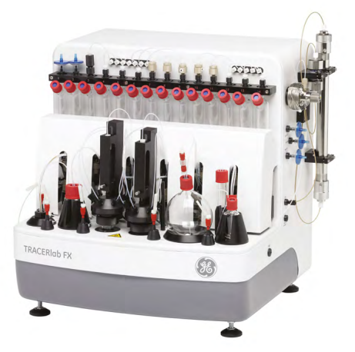
While robots may conjure images of humanoid androids, automation hardware in chemistry is simpler, including mobile robotic arms as shown in figure 3, cartesian coordinate robots, and self-contained automation systems. Mobile robotic arms are currently the most advanced and universal hardware, as they can mimic some functionality of a chemist in the lab. Mobile robotic arms can navigate the laboratory using built-in sensors. They then use their robotic arm to perform synthetic tasks such as reagent transfer and weighing.² However, they are used sparsely in research and industrial settings as they are some of the most expensive robots. A more common example of hardware is shown in figure 4, which is a self-contained, table-top synthesis unit.²⁰ This system is more specific than a robot arm, as it produces a small range of similar products for medical imaging and only works in the liquid phase.²⁰ However, it is cheaper since it is less advanced and less universal.²⁰ Cartesian coordinate robots work similarly to 3D printers and are also cheaper due to their simple construction.¹⁹
Figure 4 An image of an example of a benchtop, self-contained automation system that is common in automated medical imaging clinics and laboratories. Reproduced form TRACERlab FX2 N data sheet.²⁰
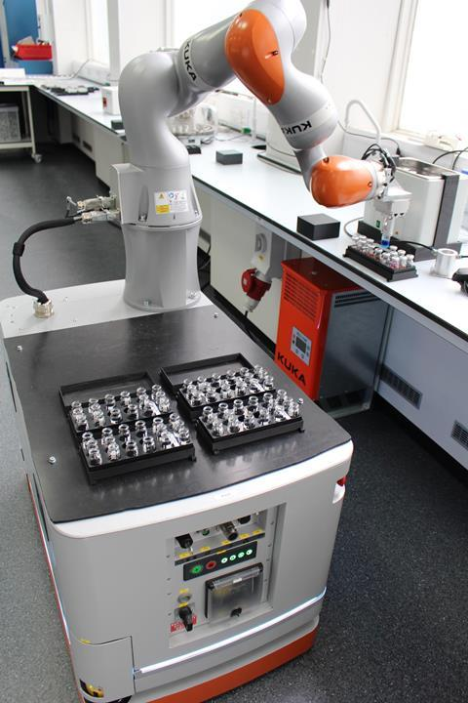
The brains that run the hardware, the automation software, consists of controller and computer-assisted organic synthesis (CAOS) software. The controller software is straightforward; it provides instructions to the hardware. For the mobile robotic arm, the controller software navigates the robot around the lab, controls the robotic arm's movements, and performs the synthetic steps.² CAOS software is broad and includes software that helps with computations, analysis, and even synthetic procedure generation. Chemists who create molecules in the lab use CAOS software to propose potential synthetic routes to produce target products. CAOS software uses its internal database to propose potential synthetic routes for target products.²¹ The CAOS software works analogously to a search engine, starting at the target molecule and linking several pre-existing reactions from its internal databases as steps to reach the final product. Both types of automation software have roots in the 1960s, so although the field of automation is indeed young, there is already a significant body of research behind modern-day automation.^{21,22}
Figure 3 A picture of the Mobile Robotic Chemist, a mobile robotic arm which autonomously navigates around laboratories, to perform synthesis and analysis. Reproduced from Burger, B et. al., 2020²
Current CAOS software is much more advanced than its conceptions in the 1960s. Early CAOS software had very limited databases of less than 100 reagents and took a significant amount of time, up to an hour, to generate one synthetic pathway.²¹ In comparison, modern software has over 2.5 million chemical reactions in their databases and can generate over 30 synthetic pathways in less than 15 minutes.²³ Other modern iterations of CAOS software can ‘read’ through existing literature from scientific journals and compile it.¹⁹ The advantages of using the literature are that these procedures include the steps and specific details about reaction conditions, including solvents, reaction timing, and temperature.¹⁹
Call to Action
The digitization of lab coats offers faster creation of materials, higher quality pharmaceuticals, and more effective solutions to climate change. Robotic hardware allows chemists to spend less time performing manual tasks within the laboratory. Software aids chemists in synthetic planning, allowing them to perform more complex tasks. However, unless we push for strict regulations for ethical automation applications, all product manufacturing may become digital once automation systems are cheaper than chemists. Then, if something happens to automation systems, there may be no chemists to fall back on, causing shortages and delays worldwide. At this point, as implementing automation systems is just becoming feasible, we need to ensure that automation becomes a solution we work cooperatively with rather than against. As automation is inevitable, unless we learn about these changes, our understanding of chemistry will become as obsolete as those lab coats.

References
(1) COP27 Reaches Breakthrough Agreement on New “Loss and Damage” Fund for Vulnerable Countries | UNFCCC. https://unfccc.int/news/cop27-reaches-breakthrough-agreement-on-new-loss-and-damage-fund-for-vulnerable-countries (accessed 2022-12-12).
(2) Burger, B.; Maffettone, P. M.; Gusev, V. V.; Aitchison, C. M.; Bai, Y.; Wang, X.; Li, X.; Alston, B. M.; Li, B.; Clowes, R.; Rankin, N.; Harris, B.; Sprick, R. S.; Cooper, A. I. A Mobile Robotic Chemist. Nature 2020, 583 (7815), 237–241. https://doi.org/10.1038/s41586-020-2442-2.
(3) Christensen, M.; Yunker, L. P. E.; Shiri, P.; Zepel, T.; Prieto, P. L.; Grunert, S.; Bork, F.; Hein, J. E. Automation Isn’t Automatic. Chem. Sci. 2021, 12 (47), 15473–15490. https://doi.org/10.1039/D1SC04588A.
(4) Moshood, T. D.; Nawanir, G.; Mahmud, F.; Mohamad, F.; Ahmad, M. H.; AbdulGhani, A. Biodegradable Plastic Applications towards Sustainability: A Recent Innovations in the Green Product. Clean. Eng. Technol. 2022, 6, 100404. https://doi.org/10.1016/j.clet.2022.100404.
(5) Journal of Cleaner Production | ScienceDirect.com by Elsevier. https://www.sciencedirect.com/journal/journal-of-cleaner-production (accessed 2022-12-13).
(6) P, T.; Somareddy, H. K.; T., S.; Gowrav, M. Impact of Automation in Pharmaceutical Industry on Roles and Responsibilities of Quality Assurance: A Review. Int. J. Pharm. Qual. Assur. 2013, 11, 74–82. https://doi.org/10.25258/ijpqa.11.1.26.
(7) Higgins, K.; Valleti, S. M.; Ziatdinov, M.; Kalinin, S. V.; Ahmadi, M. Chemical Robotics Enabled Exploration of Stability in Multicomponent Lead Halide Perovskites via Machine Learning. ACS Energy Lett. 2020, 5 (11), 3426–3436. https://doi.org/10.1021/acsenergylett.0c01749.
(8) AAPPTec Focus XC Solid Phase Peptide Synthesizer. https://www.bostonind.com/aapptec-focus-xc-solid-phase-peptide-synthesizer?language=en&currency=USD?utm_source=merchant_shopping&utm_medium=us_shopping_ads&keyword=&gclid=Cj0KCQiA-JacBhC0ARIsAIxybyMtlkv1tC1YcVcUULwl7Swlo-Y3-M4gp7-eNglX4MZkqTNrtbl2QIEaAtVoEALw_wcB (accessed 2022-11-29).
(9) Biotage Initiator Microwave Synthesizer 400W EXP US w/ Robot8 Pred Initiator+ - AV. https://www.bostonind.com/biotage-initiator-microwave-synthesizer-400w-exp-us-w-robot8-pred-initiatorplus-av?language=en&currency=USD?utm_source=merchant_shopping&utm_medium=us_shopping_ads&keyword=&gclid=Cj0KCQiA-JacBhC0ARIsAIxybyMhCFkAPKZ61TavisdgHN7GoD3usyFyWX2ZmH0ZNEoLQmVeWVVYN_IaAqJaEALw_wcB (accessed 2022-11-29).
(10) Is Sale of Universal Robots Classic Innovator’s Dilemma? - Robotics Business Review. https://www.roboticsbusinessreview.com/manufacturing/is_sale_of_universal_robots_classic_innovators_dilemma/ (accessed 2022-12-12).
(11) Lab Automation - Siemens Healthineers Canada. https://www.siemens-healthineers.com/en-ca/laboratory-automation (accessed 2022-12-13).
(12) Lim, J. X.-Y.; Leow, D.; Pham, Q.-C.; Tan, C.-H. Development of a Robotic System for Automatic Organic Chemistry Synthesis. IEEE Trans. Autom. Sci. Eng. 2021, 18 (4), 2185–2190. https://doi.org/10.1109/TASE.2020.3036055.
(13) Acemoglu, D.; Restrepo, P. Robots and Jobs: Evidence from US Labor Markets. J. Polit. Econ. 2020, 128 (6), 2188–2244. https://doi.org/10.1086/705716.
(14) C-27 (44-1) - LEGISinfo - Parliament of Canada. https://www.parl.ca/legisinfo/en/bill/44-1/c-27 (accessed 2022-12-12).
(15) The Dawn of AI Law: The Canadian Government Introduces Legislation to Regulate Artificial Intelligence in Canada | McCarthy Tétrault. https://www.mccarthy.ca/en/insights/blogs/techlex/dawn-ai-law-canadian-government-introduces-legislation-regulate-artificial-intelligence-canada (accessed 2022-12-12).
(16) Calvo, I.; Etxeberria-Agiriano, I.; Iñigo, M.; González-Nalda, P. Key Vulnerabilities of Industrial Automation and Control Systems and Actions to Prevent Cyber-Attacks. Int. J. Online Eng. IJOE 2016, 12, 9–16. https://doi.org/10.3991/ijoe.v12i01.4888.
(17) Black, E. Globalization of the Food Industry: Transnational Food Corporations, the Spread of Processed Food, and Their Implications for Food Security and Nutrition.
(18) Archer, J. W. A Brief History of the National Buildings Code of Canada. 2003.
(19) Mehr, S. H. M.; Craven, M.; Leonov, A. I.; Keenan, G.; Cronin, L. A Universal System for Digitization and Automatic Execution of the Chemical Synthesis Literature. Science 2020, 370 (6512), 101–108. https://doi.org/10.1126/science.abc2986.
(20) Doc1565254-Tracerlab-Fx2-n-Data-Sheet.Pdf. https://www.gehealthcare.com/-/jssmedia/feature/gehc/products/chemistry-systems/doc1565254-tracerlab-fx2-n-data-sheet.pdf?rev=-1 (accessed 2022-09-26).
(21) PENSAK, D. A.; COREY, E. J. LHASA—Logic and Heuristics Applied to Synthetic Analysis. In Computer-Assisted Organic Synthesis; ACS Symposium Series; AMERICAN CHEMICAL SOCIETY, 1977; Vol. 61, pp 1–32. https://doi.org/10.1021/bk-1977-0061.ch001.
(22) The Evolution of Process Automation.
(23) Homepage. https://rxn.res.ibm.com/index.html (accessed 2022-11-28).

